$DRUG Bright Minds Biosciences Long Suggestion

By Snaking
March 2025

Executive Summary
At a market capitalization of $250m, with a cash balance of $60m (EV of 190 million US$) and quarterly spending of ~$3-4m, $DRUG represents an undervalued player in the epilepsy market ahead of its Proof-of-Concept trial readout.
The difference in $DRUG’s price in comparison to similar cases (such as $LBPH before Lundbeck bought them) at the current stock price (35$) is certainly much higher than the difference between drug values.
I expect the market to react positively to the Phase 2 Open-Label data readout (most likely between April and July 2025) showcasing the first evidence of BMB-101’s efficacy in the treatment of DEEs, correcting these discrepancies.

Bull Case (12.5% Probability) >$59.5, >+70%: >70% reduction in absolute seizure frequency, no major unexpected adverse events.

Base Case (80% Probability) $45.5 to $59.5, +30% to +70%: 45-70% reduction in absolute seizure frequency, no major unexpected adverse events.

Bear Case (7.5% Probability) $7 to $17.5, -80% to -50%: little to no suggestive evidence of efficacy, or problematic occurrence of unexpected adverse events.

Context
Bright Minds Biosciences (“BMB”) initially focused on new chemical entities (NCEs) for a variety of pain indications, seizures, and neuropsychiatric disorders. By leveraging the extensive drug discovery experience of the BMB team, the company planned to create best-in-class second-generation serotonin-targeting therapeutics, aiming to have better selectivity for the targeted receptors, less frequent dosing, less susceptibility to tolerance than previously available options, ... which would logically lead to better safety-profiles, longer-lasting effects, among other benefits.
In this process of identifying new chemical entities, Bright Minds found themselves with a portfolio of selective serotonin (5-HT2C and 5-HT2C/A-receptor subtypes) agonists that were identified using high-throughput screening methods in combination with advanced molecular modeling techniques to interrogate the interaction between the drug and its targeted receptors to increase downstream signaling while avoiding off-target effects.
One of these NCEs was a compound which they ended up naming “BMB-101”, a highly selective 5HT2C agonist (which will be the focus of this report).
After the recent success of similar compounds, the company seems to be focusing its resources on the development of BMB-101 while deprioritizing other assets. A value of 0$ will be attributed to the company’s entire pipeline, except for BMB-101.
$DRUG’s CEO is Ian McDonald, a previous Investment Banker with vast experience in the M&A and capital raising worlds (having helped raise hundreds of millions for his clients in the Canadian Investment Bank he worked at) - Mr. McDonald also sold a Canadian Mining company for $160M within 1 year of starting this task. In multiple interviews, he has said in a very straight-forward manner that Bright Minds Biosciences’ job is in the clinic and that commercialization is more suitable for big, established pharma companies (even highlighting the option of selling the entire company).

BMB-101, 5-HT2C Receptor Agonism
The 5-HT2C receptor, a G protein-coupled receptor (GPCR), emerged as a potential target for epilepsy treatment due to its role in modulating neurotransmitter release and neuronal excitability.
BMB-101 is a highly selective 5-HT2C agonist in early-stage development for its clinical benefit in Developmental and Epileptic Encephalopathies (DEEs) such as Dravet Syndrome, Jeavons Syndrome and Lennox Gastaut Syndrome.
The drug is currently in a 10-week Phase II Open-Label study with 20 patients. The results of this study will be first evidence of BMB-101’s value in the treatment of DEEs.
Previous Phase I RCTs (SAD and MAD studies, n=66 total) demonstrated BMB-101 is well-tolerated and has a pharmacokinetics profile suitable for twice-daily dosing.

Other 5-HT2C Agonists Work in the treatment of DEEs
BMB-101 is not the first 5-HT2C agonist to have been clinically tested for epilepsy:
- Longboard Pharmaceuticals ($LBPH) developed bexicaserin (best comparison for BMB-101 for reasons that will be discussed in this paper), which showed a placebo-adjusted reduction in seizure frequency of 32.5% in a Phase 1b/2 RCT (PACIFIC study) in adolescents and adults with DEEs.
- Lorcaserin and Nor-Fenfluramine are less selective for 5-HT2C, but have also proven useful in the treatment of DEEs.
5-HT2C Agonists have consistently shown competitive efficacy in comparison to that of other Anti-Seizure Medications (ASMs) with different targets (Sodium channel inhibitors, Potassium channel activators, …)
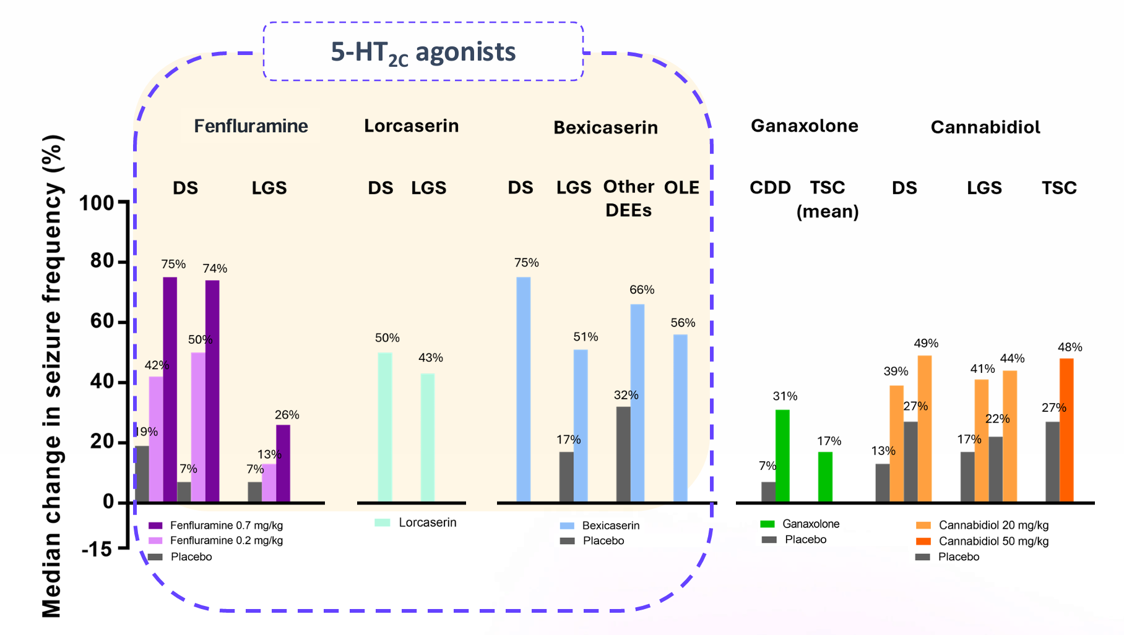
Figure 1. 5-HT2C agonists in comparison with other AEDs

5-HT2C Agonist Comparison
Between the previously mentioned compounds (BMB-101, bexicaserin, nor-fenfluramine, lorcaserin), some key characteristics distinguish their potential as Anti-Seizure Medications (ASMs).
Selectivity and Affinity
Targeting of other serotonin recepetors (mainly 5-HT2A and 5-HT2B) due to a lack of selectivity for the 5-HT2C receptor brings with it unwanted adverse events. 5-HT2A is responsible for psychedelic properties, and 5-HT2B contributes to valvular heart disease.
The following table presents the affinity and selectivity of each compound for receptors 5-HT2A, 5-HT2B, and 5-HT2C.
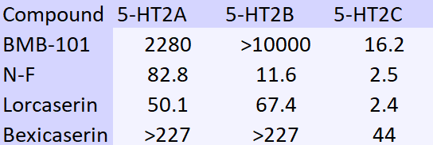
Figure 2. Affinity and Selectivity of each compound for Serotonin Receptors
Dosing Regimen
BMB-101 is BID (twice daily dosing)
Bexicaserin is TID (thrice daily dosing)
Lorcaserin is BID (twice daily dosing)

Estimating BMB-101’s Value in the DEE market
Because there is a recent case of a company who developed and subsequently sold their own 5-HT2C compound, an reasonable range of valuations for BMB-101 can be reached.
$LBPH, Longboard Pharmaceuticals, was a clinical-stage biotech that was acquired by Lundbeck in October 2024 for $2.6B ($2.5B net of cash). The company’s only asset at this time was bexicaserin, a selective 5-HT2C superagonist which had undergone a randomized, double-blind, placebo-controlled Phase 1b/2 trial in which it showed a placebo-adjusted reduction in seizure frequency of 32.5%, and half of a Phase 2 Open-label extension of the previously mentioned trial.
Previously to Lundbeck’s acquisition, the company already had a 1.5B$ valuation (1.4B$ EV). When the first efficacy data for bexicaserin was announced (Phase 1b/2 readout), $LBPH’s share price increased from 6$ to 25$, a 740M$ marketcap increase in ~3 days.
Both bexicaserin and BMB-101’s IP Protections expire in 2041, making them even more suitable for comparison.
Given the similarities between bexicaserin and BMB-101, and having in mind the disparities between the valuation of the two (even excluding the acquisition price, a 500% difference) – this phenomenon can only be explained by the market’s uncertainty about BMB-101’s efficacy.
I am confident that BMB-101 will demonstrate equivalent efficacy to that of bexicaserin in this open-label trial (~50-60% reduction in seizure frequency, given there is no control group) for the following reasons:
- Pre-clinical models of Mice (6-hz) and zebrafish (scn1ab) have shown reduced seizure duration and activity, in accordance with that of bexicaserin’s results in similar models.
- BMB-101 showed 5HT2C target engagement measured by Prolactin % change (5-HT2C agonists, such as lorcaserin and bexicaserin, are known to increase prolactin plasma levels via a central mechanism in the hypothalamus) and induced qEEGs typical of other anti-seizure medications in this class.
Given the previously mentioned price discrepancies, I expect the market to react positively upon favorable efficacy in this trial (defining favorable efficacy as similar/equal to that of bexicaserin).

Assessing the Associated Risks
A major point in favor of bexicaserin is that this compound is the only superagonist in the clinic targeting 5HT2C.
Admittedly, this phase 1 data comes from a single-arm, open-label trial at just a single site in Australia, with plenty of room for sketchy data and fraud (Australia is a terrible country for data integrity for various reasons). (this information could be interpreted a feature, not a problem)
The lack of a placebo comparator may add a layer of subjectivity to the interpretation of results by the market.
References
Bright Minds Biosciences INC. LISTING STATEMENT FORM 2A
2102060946158620.pdf
PACIFIC Study Topline Data
Microsoft PowerPoint - Ex. 99.2 PACIFIC TL Data Slides
BMB-101 and Biased 5-HT2C Agonism: A Novel Approach for Sustained Epilepsy Management
5-HT2C-biased-agonism-poster-AES_2024-Final.pdf
Bright Minds Biosciences Website
Bright Minds - A Biotechnology Company | Drug Developer

